Name :SK.Kashifa

Registration no :192121135

Airplane reservation system :

Class diagram :

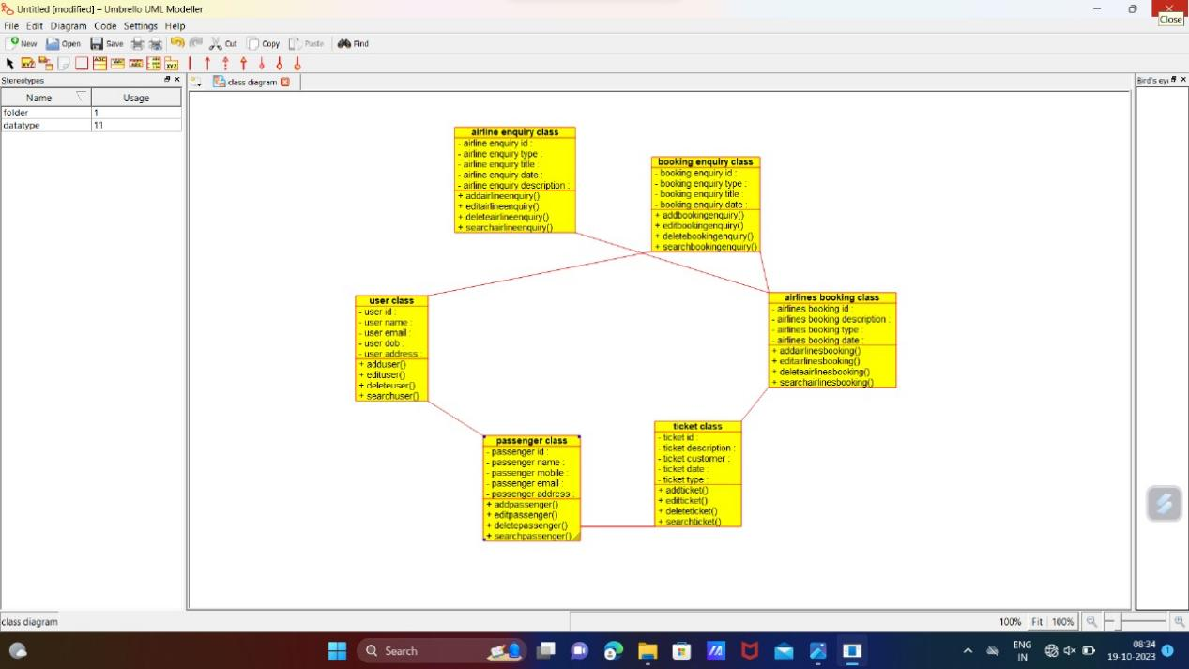

Sequence diagram :

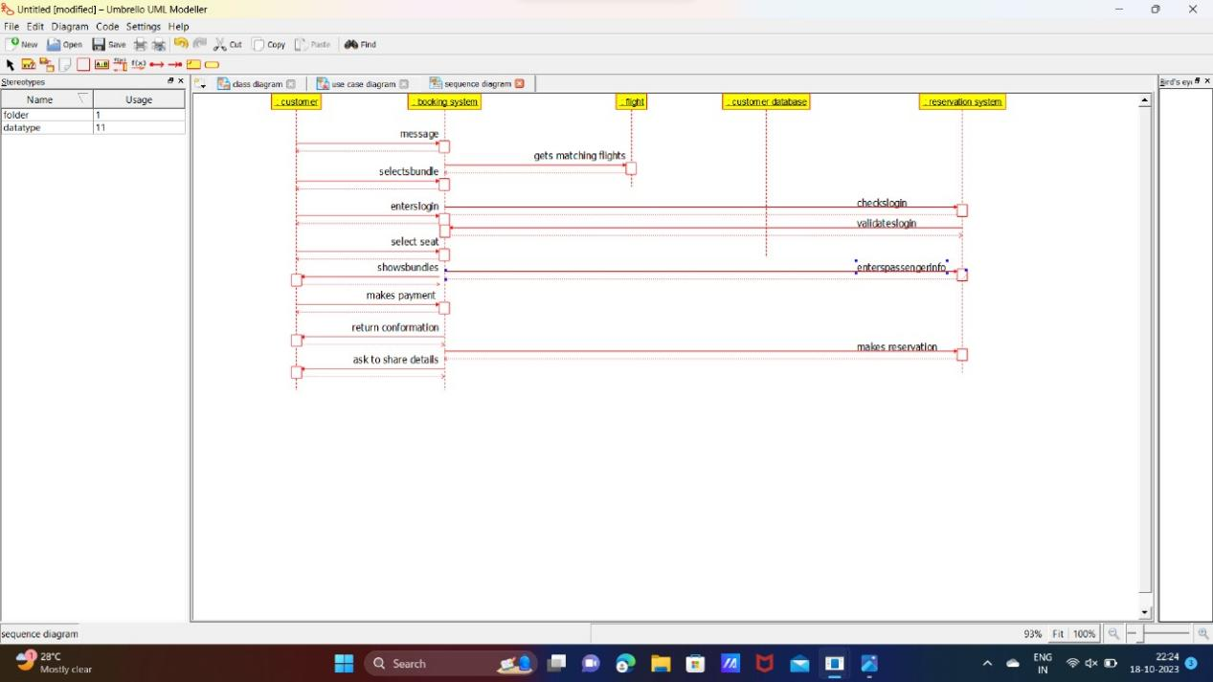

Usecase diagram :

